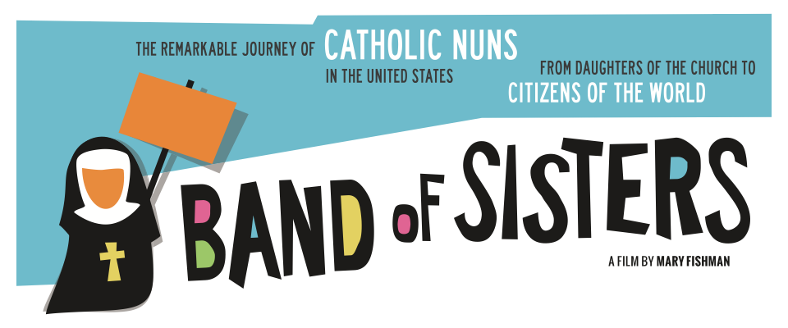
Band of Sisters - a new documentary film about Catholic sisters in the U.S.
and their work for social justice - IS COMING TO DES MOINES!

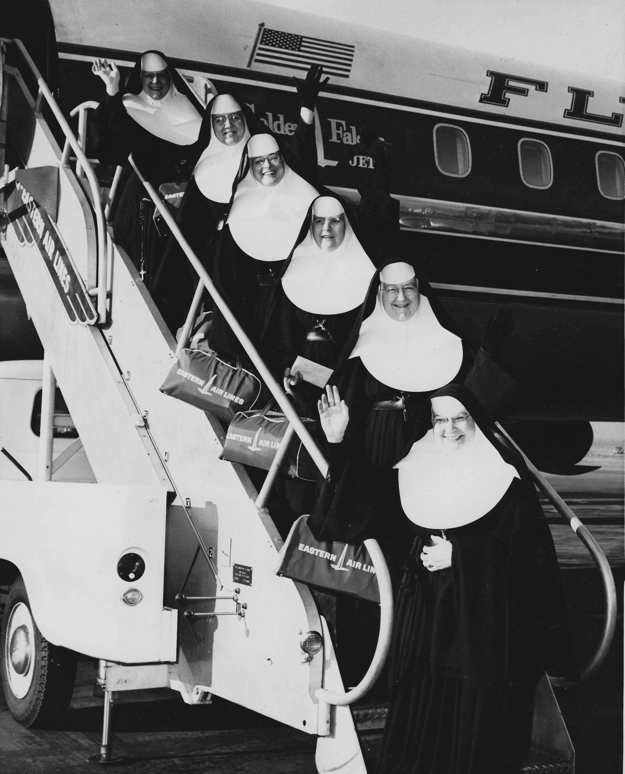

HOLY TRINITY CATHOLIC CHURCH
2926 BEAVER AVENUE, DES MOINES
SUNDAY MAY 5 at 1:00 PM

Director Mary Fishman in person, with local sisters,
for audience discussion

Free will offering - $10 suggested donation

Please call Sr. Elaine Hagedorn, CHM or Sr. Jeanie Hagedorn, CHM
at 515-277-6617 with questions.

For information about the film: http://bandofsistersmovie.com

