Chicago filmmaker spent 8 years on new documentary 'Band of Sisters'

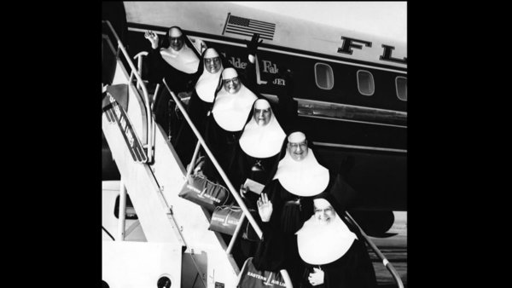
'Band of Sisters' (September 13, 2012)
Nina Metz
Chicago Closeup
3:52 p.m. CDT, September 13, 2012

"You didn't really have (to) think much for yourself," a nun says of her early years, in the new documentary "Band of Sisters," which has its world premiere at the Siskel Film Center this week. "All that went unchanged for years and years and years — until Vatican II."
Over a period of eight years, Chicago filmmaker Mary Fishman talked with a wide assortment of nuns, including a key pair working locally, who experienced one of the most significant transformations of the Roman Catholic Church in the 1960s and are now, almost half a century later, experiencing a push-back from Rome for embracing the very concepts put forth in the Second Vatican Council. (Those changes led to, among other things, a noncloistered, non-habit-wearing lifestyle for those who prefer it.)
"I did exactly as the church asked me," as one nun puts it, "and now the church is looking at me like, 'Where have you come from? Who are you?'"
- NINA METZ

- Bio | E-mail | Recent columns
The before-and-after sentiment is best captured in this anecdote from Sister Margaret Brennan, a former president of the Leadership Conference of Women Religious, an organization that was recently the subject of criticism from Rome:
"When John XXIII was elected (in 1958), I remember very distinctly we had pictures of the cardinals all on the wall, and we were wondering, would it be this one or that one or the other one? And then when it was announced, and we saw the picture of this man with this great big face, we just said, 'Who is this man?' He was up in his 70s, ya know? And it's just one of those miracles of time that somebody comes in like this, you see, who just opened the window and said, 'We need fresh air in the church.'"
At their peak in 1965, there were roughly 180,000 nuns in this country. The number is closer to 56,000 today. Last week I spoke with Fishman about the film and her perspective on American nuns today.
Q: What prompted you to work on a documentary about Catholic nuns?
A: The idea came from a book my sister gave me called "Aging With Grace" about nuns being involved with an Alzheimer's study, and it was a book that brought the nuns to life as real people. I had been educated in Catholic grammar school and high school and college, but I really hadn't had anything to do with them for a long time and still thought of them as I had when I was a kid, when you didn't know what color hair they had or didn't think about the fact that they came from families and had parents and brothers and sisters. Or that they would have a beer sometimes.
So that started to change my thinking: They turned out to be very warm, with good senses of humor, and still wanted to help even though they were getting into old age. They just wanted to be of service to humanity. And I thought, maybe there's a story in there for a film, and I started reading about the history of nuns in this country. They've been here 300 years. I was just amazed at all the institutions they've built and all the things they've accomplished. And for (all) that they've done, they still get reduced to a stereotype of the stern disciplinarian, or they're out of touch with reality and simple-minded. And that didn't seem fair to them.
I started to narrow the focus down to Catholic sisters and their work for social justice after Vatican II. How did the nuns experience Vatican II? How did their thinking change about what their mission should be?
Q: How did you meet the two Chicago nuns (and roommates) Sister Pat Murphy (83) and Sister JoAnn Persch (78) who lobbied the state Legislature to pass a law allowing religious groups to minister to those about to be deported?
A: They live three blocks from me in Morgan Park (on the South Side) in a rented house. We were on our parish social justice committee together, and they were right at the beginning of this venture of finding out what's going on at these detention centers, and they were trying to get inside the detention center (in Broadview) and inside the jail in McHenry County, so I thought it would be good to follow them and see how the story turned out.
Q: Was it a coincidence that you started filming just as the Vatican began making visits to the United States to evaluate the nuns here?
A: I had already been filming a couple years when that was announced in 2009. The fact that it happened was a big surprise and a shock to everyone, but there had been conflict for many, many years. This was kind of like one manifestation of it or an increase of it.
We don't know what the Apostolic Visitation report says. That's the secret report that they talk about that was quietly sent to Rome at the beginning of this year. The only wind that we've gotten of what that report might say came out in April, when they issued this doctrinal assessment of the Leadership Conference of Women Religious.
Everyone uses the word "scathing" for that report. The leadership group was critiqued by the Vatican because they spend too much time focusing on issues of social justice and poverty and not enough time promoting the doctrines of the church about homosexuality or, I should say, against homosexuality and abortion and the doctrine on the male-only priesthood and the primacy of the Catholic faith.
Part of the criticism from the Vatican was that (the nuns) don't actively promote the church's official positions on those issues, but the sisters say they try and focus on the areas that the bishops don't focus on as much, like poverty issues or health care.
Q: I was struck by how even-keeled they all are, even when there's disagreement.
A: I think a part of it is that they're so schooled in nonviolence that they're nonviolent in their way of speaking too. They're nonconfrontational. They're trying to come from a place of love and inclusiveness. And even though they might have opponents, they don't label them or demonize people, and maybe in that way they come across as a bit more reflective.
Q: Uniforms can make a powerful impact, and I'm wondering if any of the nuns told you they missed wearing their habits?
A: It wasn't even a question I asked because it was so obvious to me that the nuns I was talking to seemed totally happy not wearing habits, because it was something that separated them from people. If Sister JoAnn (at the detention center) had gotten better treatment from a guard because she was wearing a habit, then that would mean the nuns would be less in touch with what the average person goes through. I think they're better able to know what people need and what they suffer, because they suffer with them.
"Band of Sisters" screens this week at the Siskel Film Center. Filmmaker Mary Fishman will be there to hear from the audience after most screenings; Sister Pat Murphy and Sister JoAnn Persch will be at Friday's screening. Go to siskelfilmcenter.org.

